Name: Loic Galland

LNU email: [lg222sv@student.lnu.se](mailto:lg222sv@student.lnu.se)

GitHub Release:

**Task 1 - Test Plan**

**Objectives**

The objectives of testing this iteration is to find bugs, issues with the code that will then be fixed in the last iteration.

**What to test?**

We intend to test the UC2 (“Play Game”) because it is the main part of the game. And we want to make sure that the game is doing what it is supposed to do. We are going to specifically test the methods isLetterInWord, getStringReprensation and createUnderscoreArray. These three methods are important methods that make the application works and therefore the methods have been selected to be tested.

**How to test?**

We are going to create manual testing and automated testing (using JUnit) to be able to determine if the application is working according to the requirement.

**Time Plan**

|  |  |  |
| --- | --- | --- |
| **Task** | **Estimated** | **Actual** |
| Manual Test Case | 1h | 1h30min |
| JUnit test | 1h30min | 2h |
| Running test | 40 min | 20min |
| Checking the code | 30 min | 25min |
| Report of Testing | 30 min | 1h |

**Task 2 – Manual Test Cases using the client application**

**TC2.1 Win Game**

**Use Case Tested:** UC2 (“Play Game”)

**Short Description:** This test case is testing if the system shows the correct text when the player wins the game for UC2.

**Preconditions:** UC1.

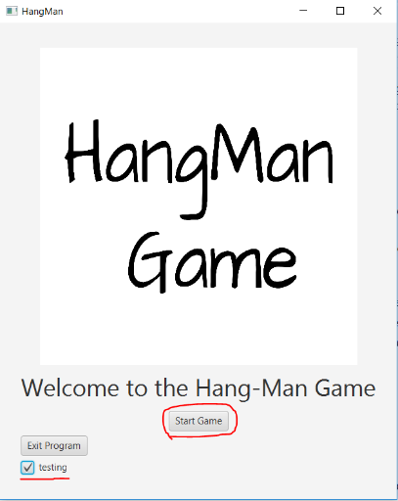**Test steps**

* Tick the box “testing”.
* Press the “Start Game” Button.
* Write “h” and Press the Button “GUESS”.
* Write “e” and Press the Button “GUESS”.
* Write “l” and Press the Button “GUESS”.
* Write “o” and Press the Button “GUESS”.

**Expected**

* 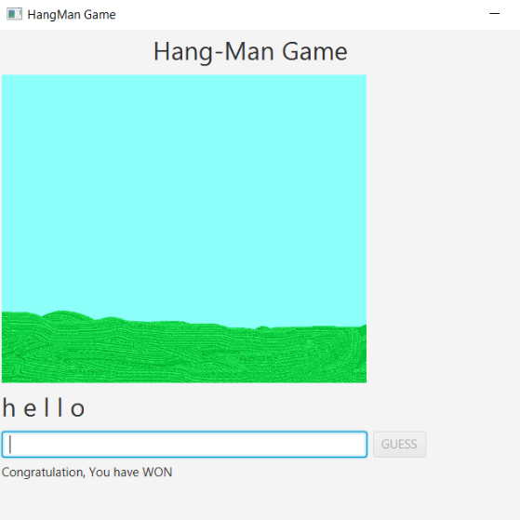The system should show the text “h e l l o” under the picture and show the text “Congratulation, You have WON”.

**Results**

Did the Test succeed: 

Comments:………………………………………………………………………………………………………………………………………………………………..………………………………………………………………………………………………………………………………………………………………..………………………………………………………………………………………………………………………………………………………………..

**TC2.2 Lose Game**

**Use Case Tested:** UC2 (“Play Game”)

**Short Description:** This test case is testing if the system shows the correct text when the player loses the game for UC2.

**Preconditions:** UC1.

**Test steps**

* 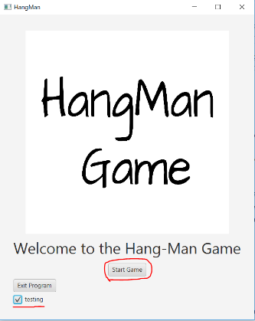Tick the box “testing”.
* Press the “Start Game” Button.
* Write “q” and Press the Button “GUESS”.
* Write “p” and Press the Button “GUESS”.
* Write “m” and Press the Button “GUESS”.
* Write “w” and Press the Button “GUESS”.
* Write “u” and Press the Button “GUESS”.
* Write “d” and Press the Button “GUESS”.
* Write “a” and Press the Button “GUESS”.

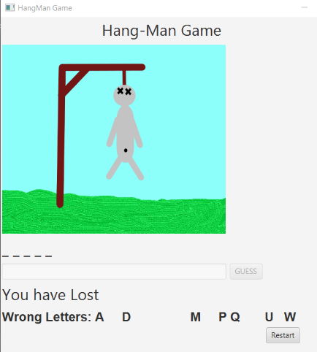

**Expected**

* The system should show the text “You have Lost” under the picture.
* The system should show the text “Wrong Letters: A D M PQ U W”.
* The system should show a Button “Restart”.
* The image should show the dead hang man.

**Results**

Did the Test succeed: 

Comments:………………………………………………………………………………………………………………………………………………………………..………………………………………………………………………………………………………………………………………………………………..………………………………………………………………………………………………………………………………………………………………..

**TC2.3 Win Game When Writing full Word**

**Use Case Tested:** UC2 (“Play Game”)

**Short Description:** This test case is testing if the system shows the correct text when the player wins the game for UC2 when typing the full word directly.

**Preconditions:** UC1.

**Test steps**

* Tick the box “testing”.
* Press the “Start Game” Button.
* Write “hello” and press the button “GUESS”

**Expected**

* 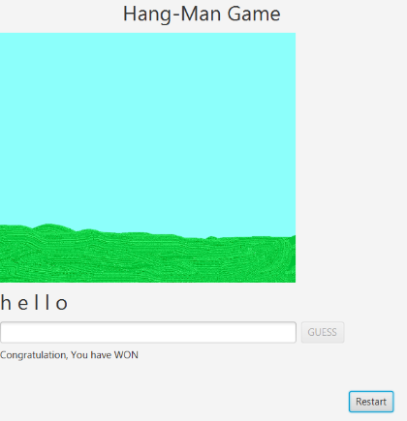The system should show the text “Congratulation, You have WON” under the picture.
* The system should show a Button “Restart”.
* The image should show a landscape without pole.

**Results**

Did the Test succeed: 

Comments:………………………………………………………………………………………………………………………………………………………………..………………………………………………………………………………………………………………………………………………………………..………………………………………………………………………………………………………………………………………………………………..

**Task 3, Unit Test**

**Method from the source code that need to be tested:**

**Method isLetterinWord:**

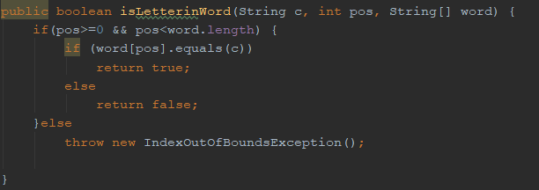

**Method getStringRepresentation:**

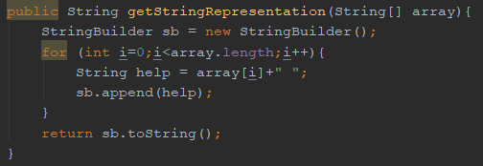

**Method createUnderscoreArray:**

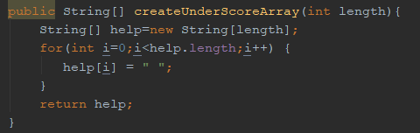

**Methods for the automated tests in Junit 5:**

**JUnit methods to test the source code method isLetterinWord:**

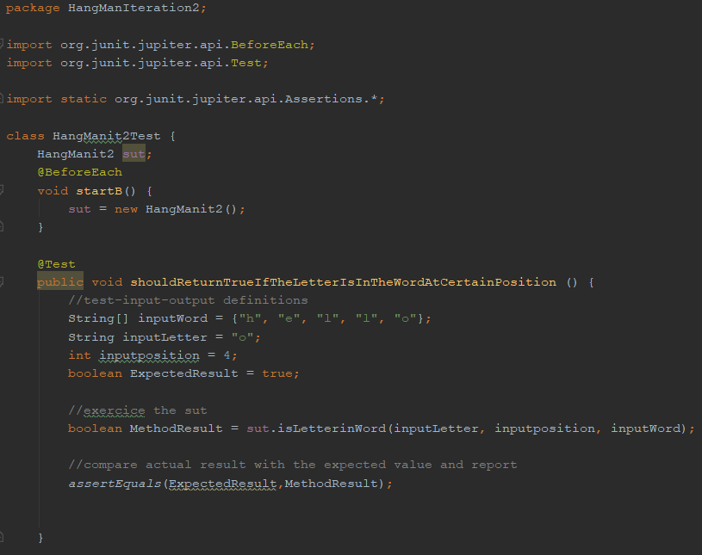

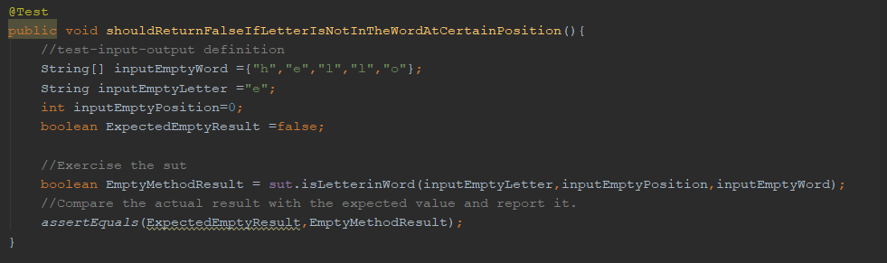

**JUnit method to test the source code method getStringRepresentation:**

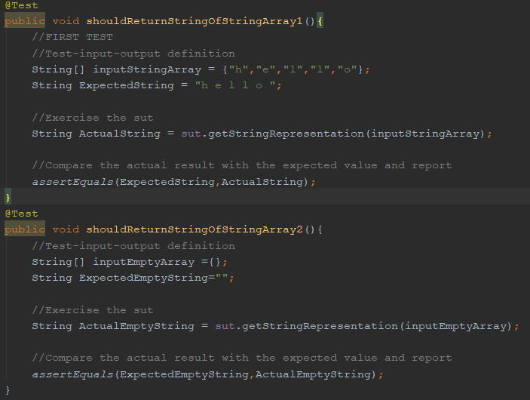

**JUnit method to test the source code method createUnderscoreArray:**

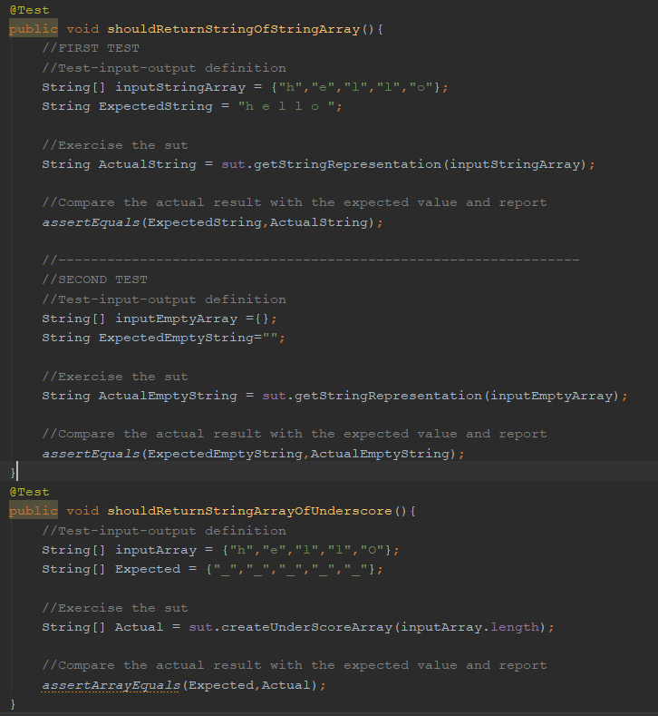

**Results of the Automated Tests in JUnit:**

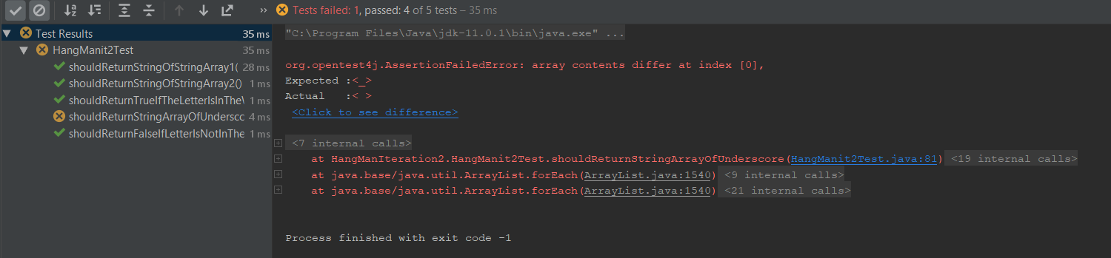

The first 3 test methods were successful. However, the test method “shouldReturnStringArrayofUnderscore” did not work as expected.

**Task 4 - Reflection:**

This assignment made me realise how important testing is in the building of an application. I realised that I had some of the code that was not working but it was not visible when running the application. It also made me realised that was a mess and that it was not implemented in a way where I will able every single part of my code. I will take this into account for the final iteration of this project and for my future projects.